Web Engineering

(Project Report)

Astra (Opensea.io clone)

Table of Contents

**Project Requirements2**

**Motivation3**

**Description4**

**ScreenShots5**

Home Page

Wallet Connection

Rankings

Activity

Collections

NFTs

Resouces

**Funcitonal and Non-functional Requirements16**

**Conclusion17**

Project Requirements

The following are the important tasks to be carried out in the project.  
  
(Semester project is a group activity. The number of group members must be 3 or 4).

1. Choose any topic of your interest for which you want to develop a website e.g. social networking, content management systems, online shopping stores (e-commerce), online portfolios, blogs, forums, news, fashion, etc. You can also extend the topic you have worked on in assignment 2/3. Come up with fresh ideas!!!
   * Rule of thumb: You must be able to create at least 20-30 different web pages. In the case of single-page applications, you must be able to demonstrate that your website is comparable with a website of 20-30 pages (in terms of the amount of work/development).
2. Create at least 15 different dynamic web pages for your website.
3. Use external CSS and javascript/jQuery files only. Use maximum concepts you have learned in the lectures to design and develop your website.
4. The layout of your website must be div-based and the website must be responsive in nature (RWD). For this, you will use the bootstrap  library
5. Use AJAX in at least one of the web pages of your website. You can use AJAX for product rating, for live chat, for comments, or in any other way.
6. The website must be dynamic i.e. no static content. All of the data must be retrieved from the backend database using PHP.
7. Use MVC architecture pattern by employing the Laravel framework. You should use Blade templating and Eloquent ORM to create dynamic web pages.
8. Write a small report (at least 10 pages) about the potential website you are going to develop. The report must include the following sections:

* Introduction including motivation
* Description of the website e.g. type of content, how you will organize it (sections, subsections, web pages, etc.)
* Description of the layout of the website (must be responsive web design)
* Screenshot of the layout and all pages along with a brief description
* Functional and non-functional requirements
* Conclusion

MOTIVATION

This project was chosen because recently the use of blockchain and various cryptocurrencies in different marketplaces has gained popularity at tremendous rate and thus the idea was intriguing to us. Further, the high demand factor of these marketplaces seemed very motivating. Building an NFT- market place frontend has challenged us in multiple areas and will helped us acquire knowledge in different domains. By adding backend functionality, we have built a full-scale project that we can use in future. Several different libraries and software’s were required for this which helped us master skills beyond what is being taught in the class.

The following steps were be followed to build this project:

1. Front-end development of the marketplace using HTML, CSS, JavaScript, jQuery, Php and Laravel
2. Navigation of the website will include the following:
   1. Home page (Login, signup, explore, create)
   2. My account page (profile, favorites, watchlists, my collections, settings)
   3. Marketplace (All NFTs, art, collectibles, sports, photography, music, sports, trading cards, virtual worlds)
   4. Resource page (Help center, platform status, partners, blog, news)
   5. Stats Page (rankings, activity)
3. Backend development of the marketplace by choosing a blockchain and developing smart contract which helps in carrying out the operational tasks in the NFT marketplace.
4. Integrating the front and backend of the project and making them interact using the smart contracts.

Description and Layout

* 1. Name: Astra
  2. Type of content
* The website is an NFT-marketplace that helps users to explore/create/ buy and sell NFTs.
* Explore: Through the exploration part of the website, the user can view all the possible categories of NFTs available. The main explore page has different categories that can be viewed. Each category further has its own page through which the user can view all NFT collections of that specific category. Further, each collection page further has its own main page that allows users to view all the unique NFTs that belong to that collection.
* Stats: In this part of the website the user can view the ranking of NFT collections based on different filters including Owners, categories, and Items available. Secondly, the user can view the activity going on in the website. The activity page shows the current status of events occurring. The events can be filtered base don listings, sales, transfers, and offers. The detail of each even is given alongside.
* Resources: This part proves users with the main resources he/she might need to use the website. There are also detailed guidelines on how they can use it. The Help center pages help in different areas like buying, selling, creating, FAQs, User Safety, partners, and developers. The partners provide details to people who might want to collaborate. The Newsletter page allows user to give their credentials so that they can be informed of any updates.
* Account: In the account section, the user can views details of his/her account. The summary of their collections, the NFTS they have liked, their transactions etc.
* Wallet: The wallet allows users to connect to their respective blockchain.

1. Layout

* Header: Contains a navigation bar with website logo, and search bar.
* Body: Contains content of each page, and sections where required.
* Footer: Provides a complete sitemap of the website.
* Responsive and dynamic web pages have been designed.

Screenshots

1. **Home**

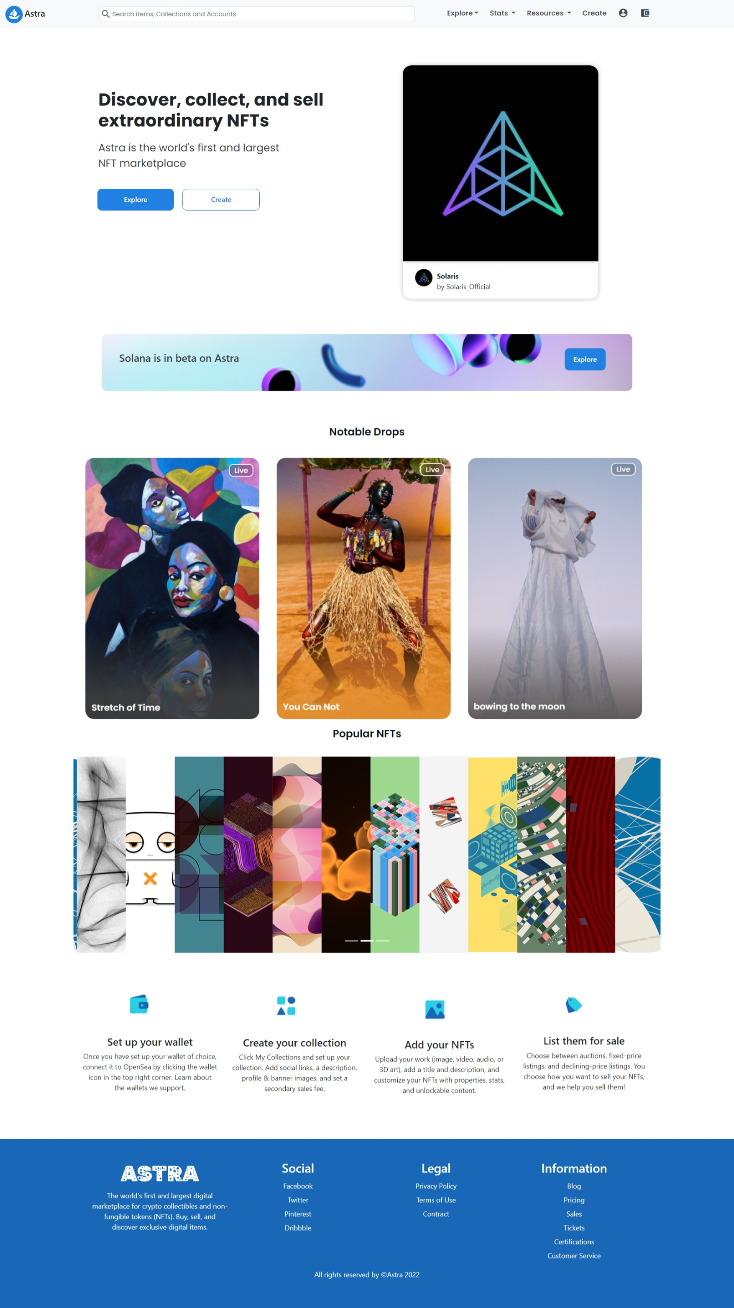

Landing page of the website

1. **Wallet Connection**

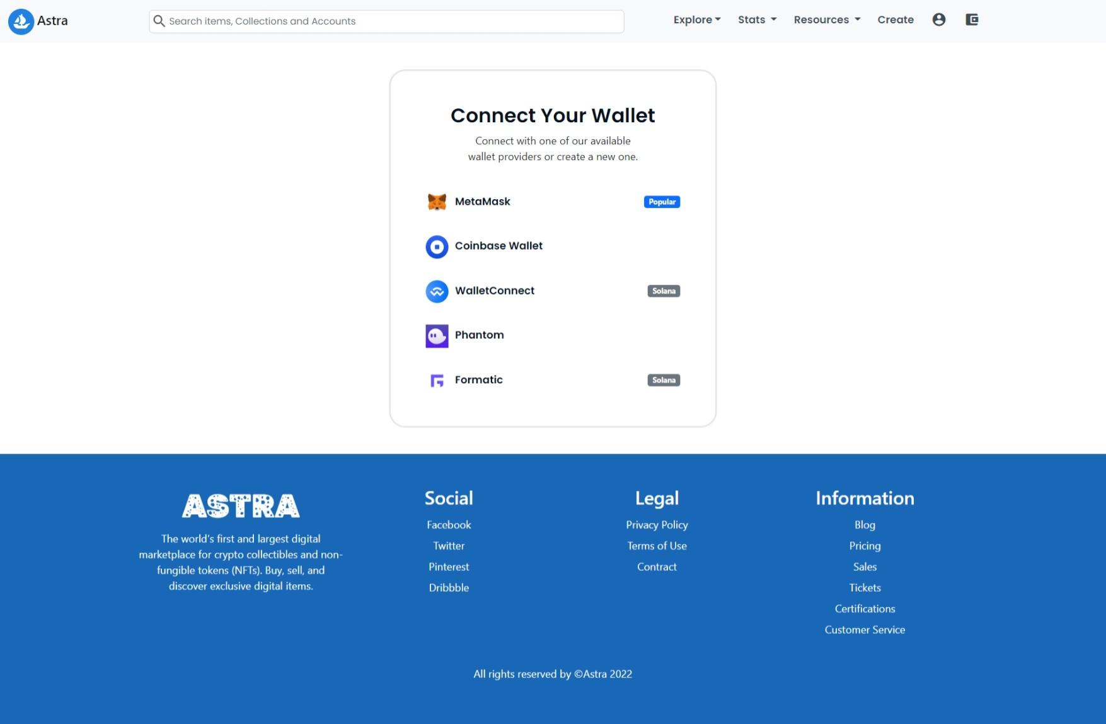

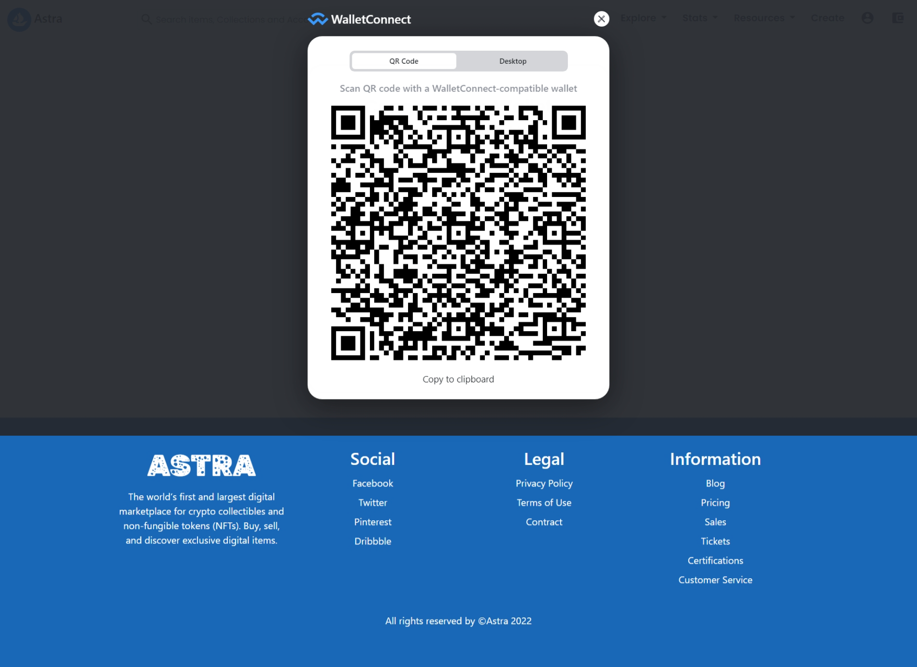

Users can connect to our website by simply scanning the QR code through their crypto wallet app installed on phone. Once connected, they can perform transactions through their phone while being active on the website!

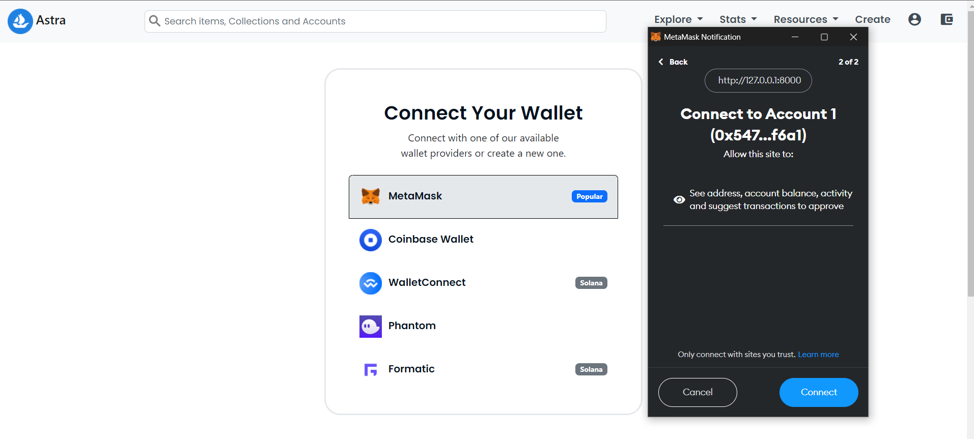

We have integrated multiple blockchain wallets into our website as can be seen above. Once a user connects their crypto wallet, they are redirected to the accounts page.

1. **Explore (11 dynamic pages)**

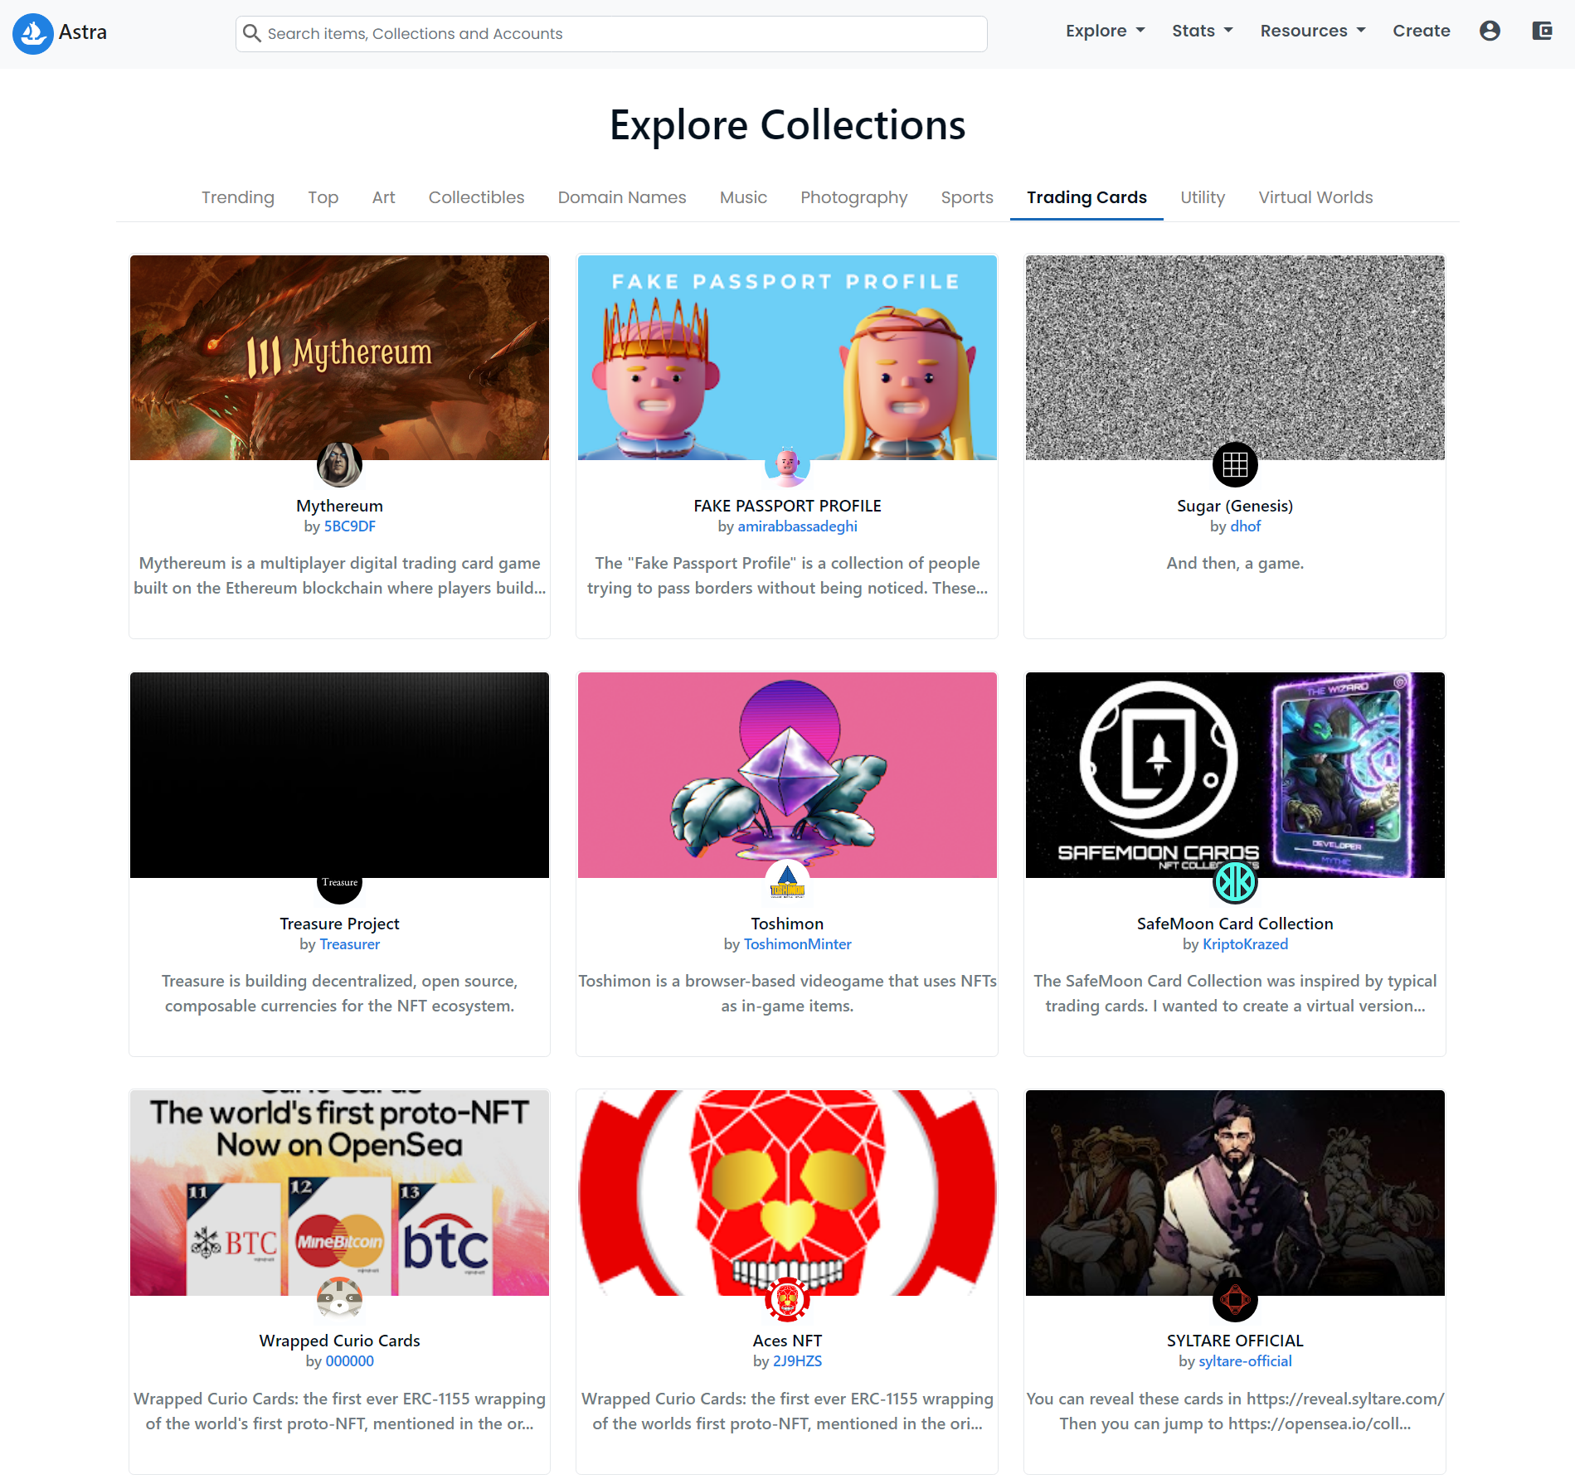

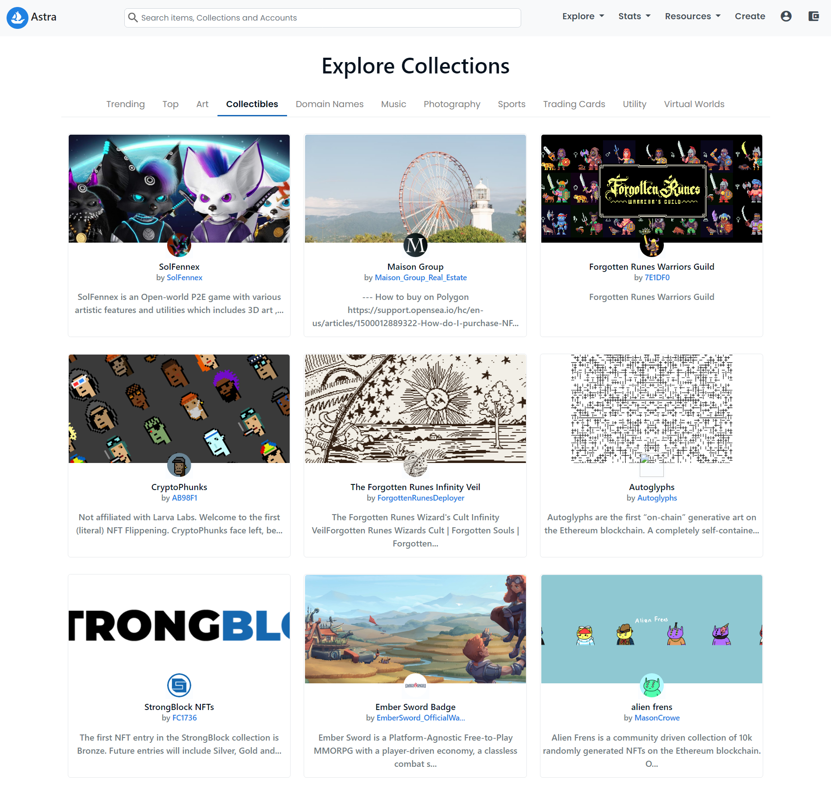

User can explain different NFT cocllection by going to the explore page. Each collection card is clickable has its own page. Thus, there are over 100+ dyanmic pages in total.

1. **Search (leads to dynamic pages)**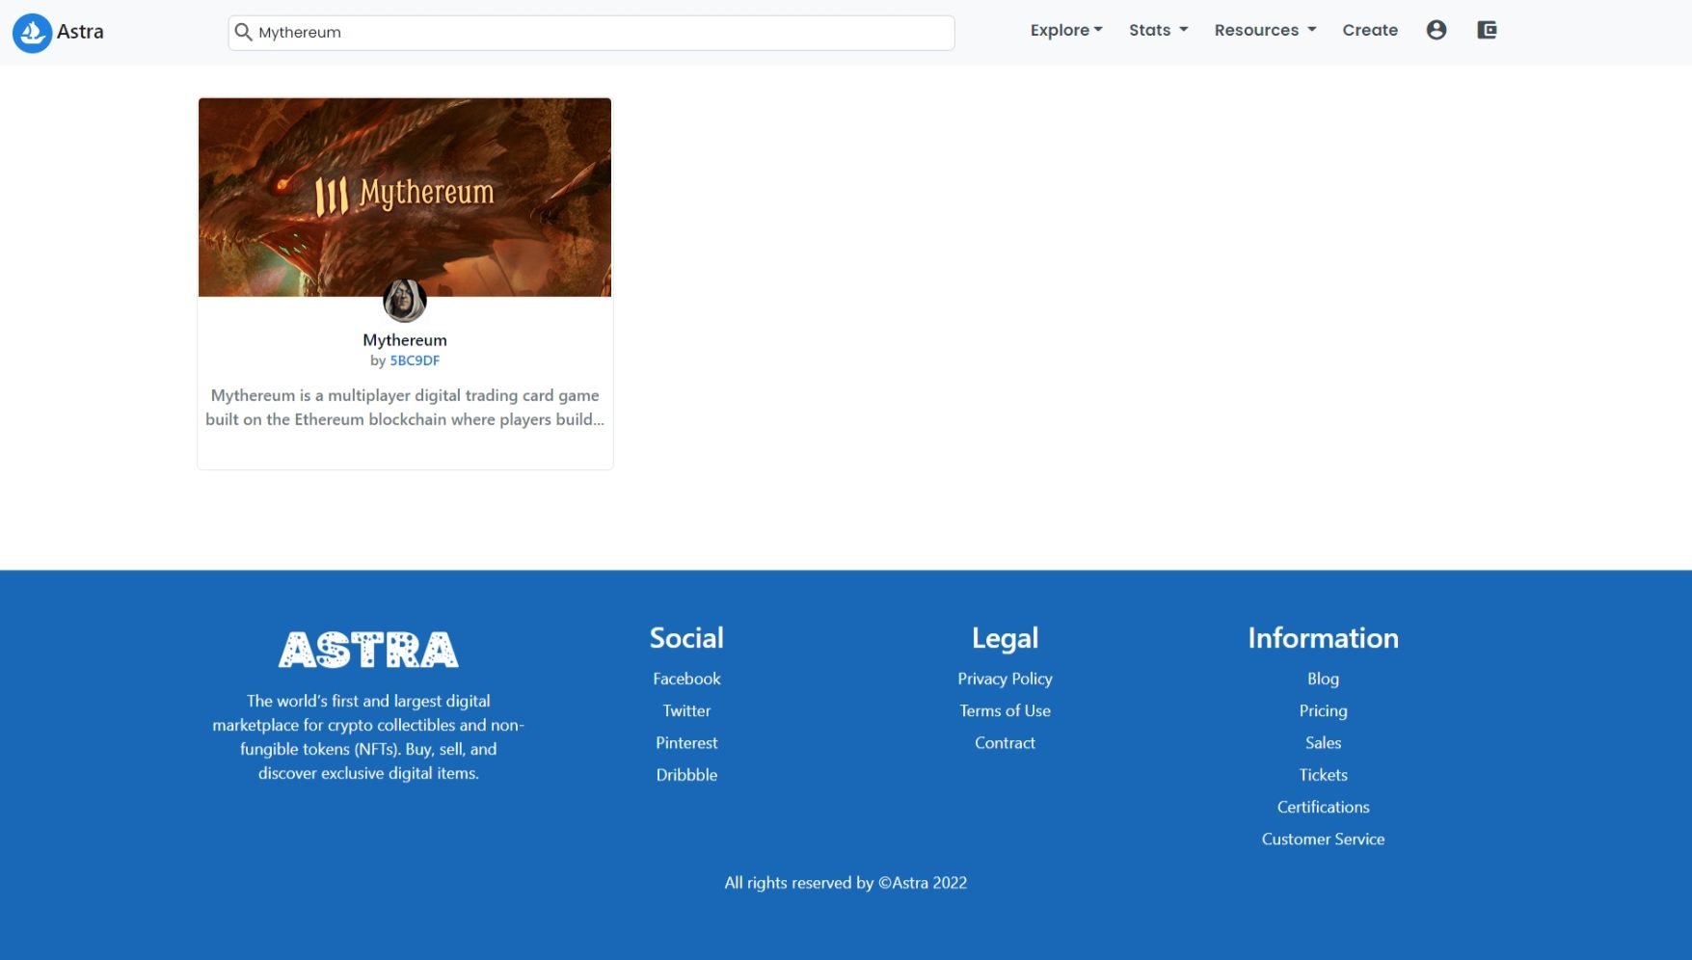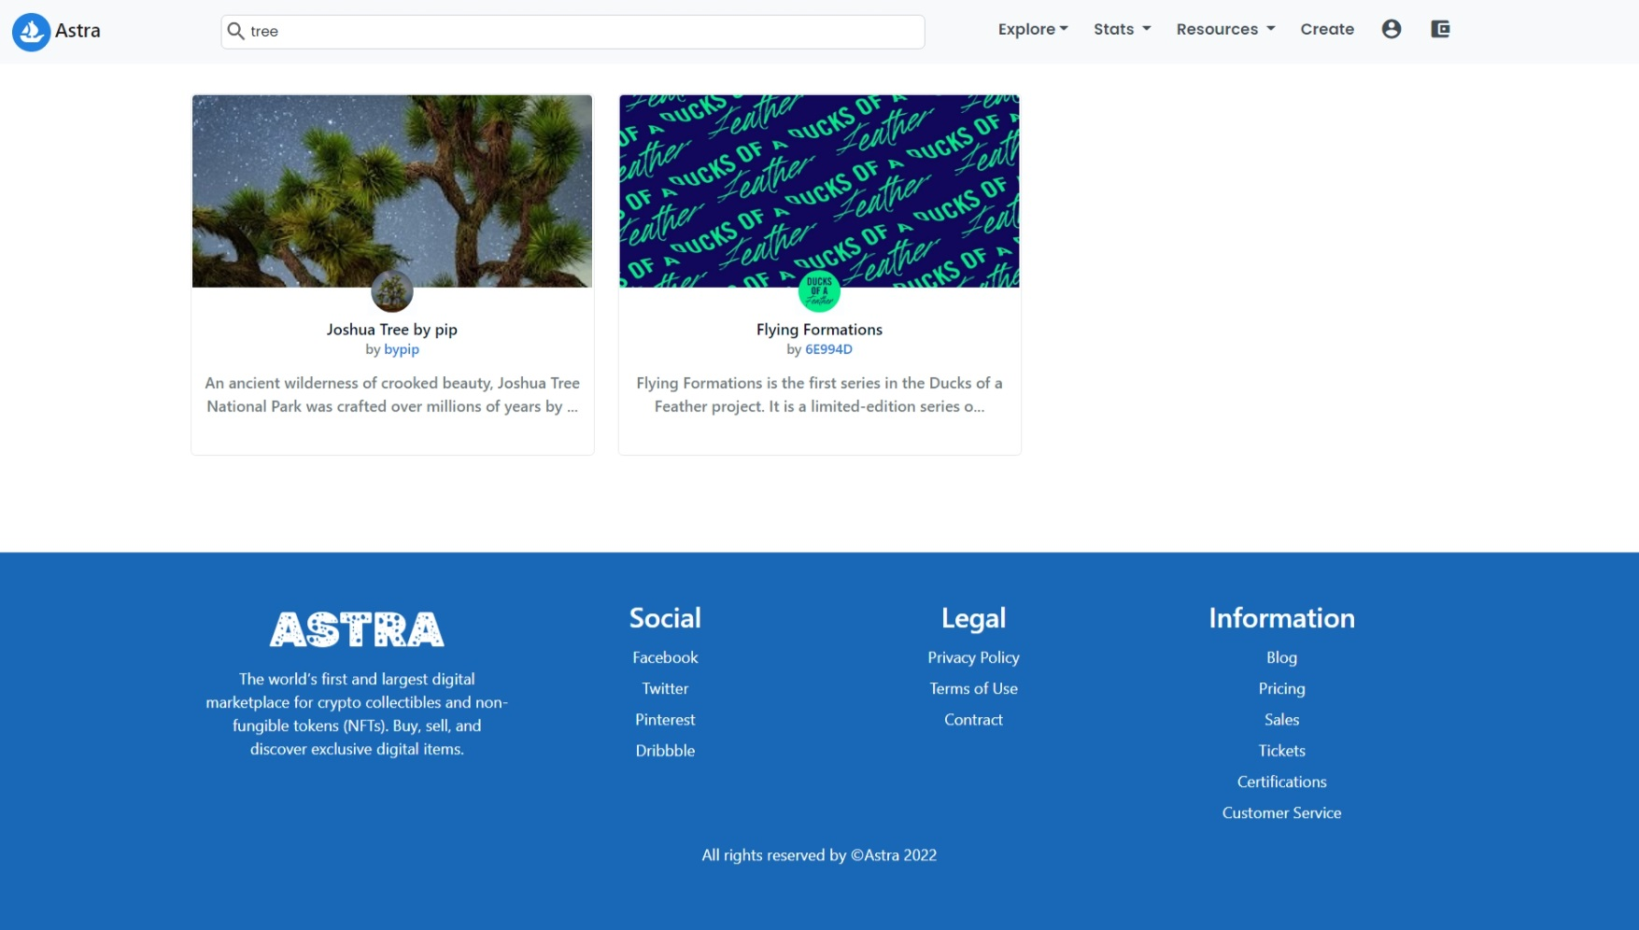

Users can search for NFTs or NFT collections or even other users through the search bar.

1. **Rankings (15+ dynamic pages with different filters)**

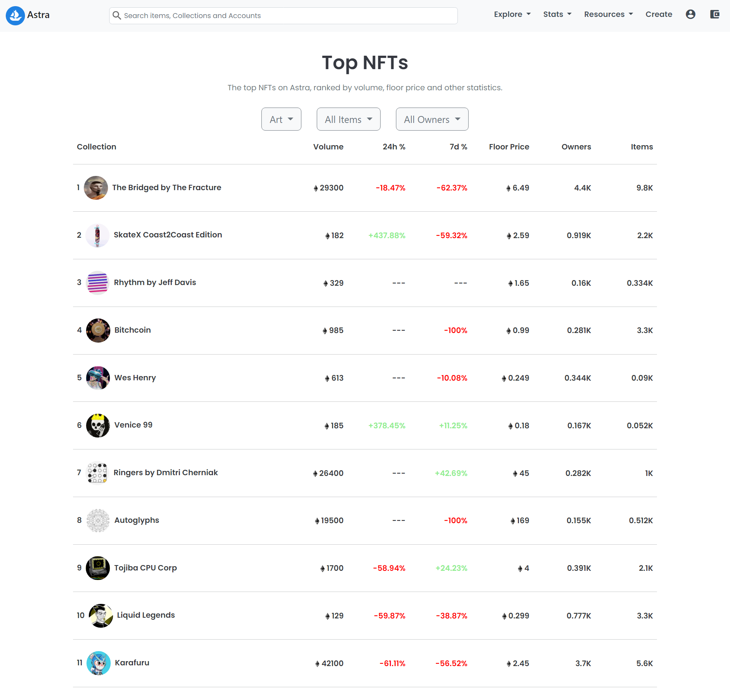

This page shows how well an NFT has been performing. It shows different stats like its weekly and monthly price changes. It also shows how much cryptocurrency has been traded by selling and buying of NFTs as well as other statistics.

1. **Activity (5 dynamic actions/pages)**

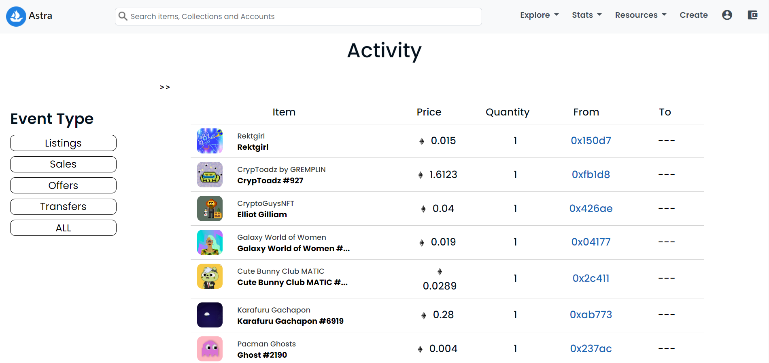

This page shows the live buying and selling of an NFT. It shows different info such as if a buy order was created, if a sell order was created, if a purchase was successful, if an NFT was listed on the marketplace etc.

1. **Collection Categories (9 dynamic pages)**

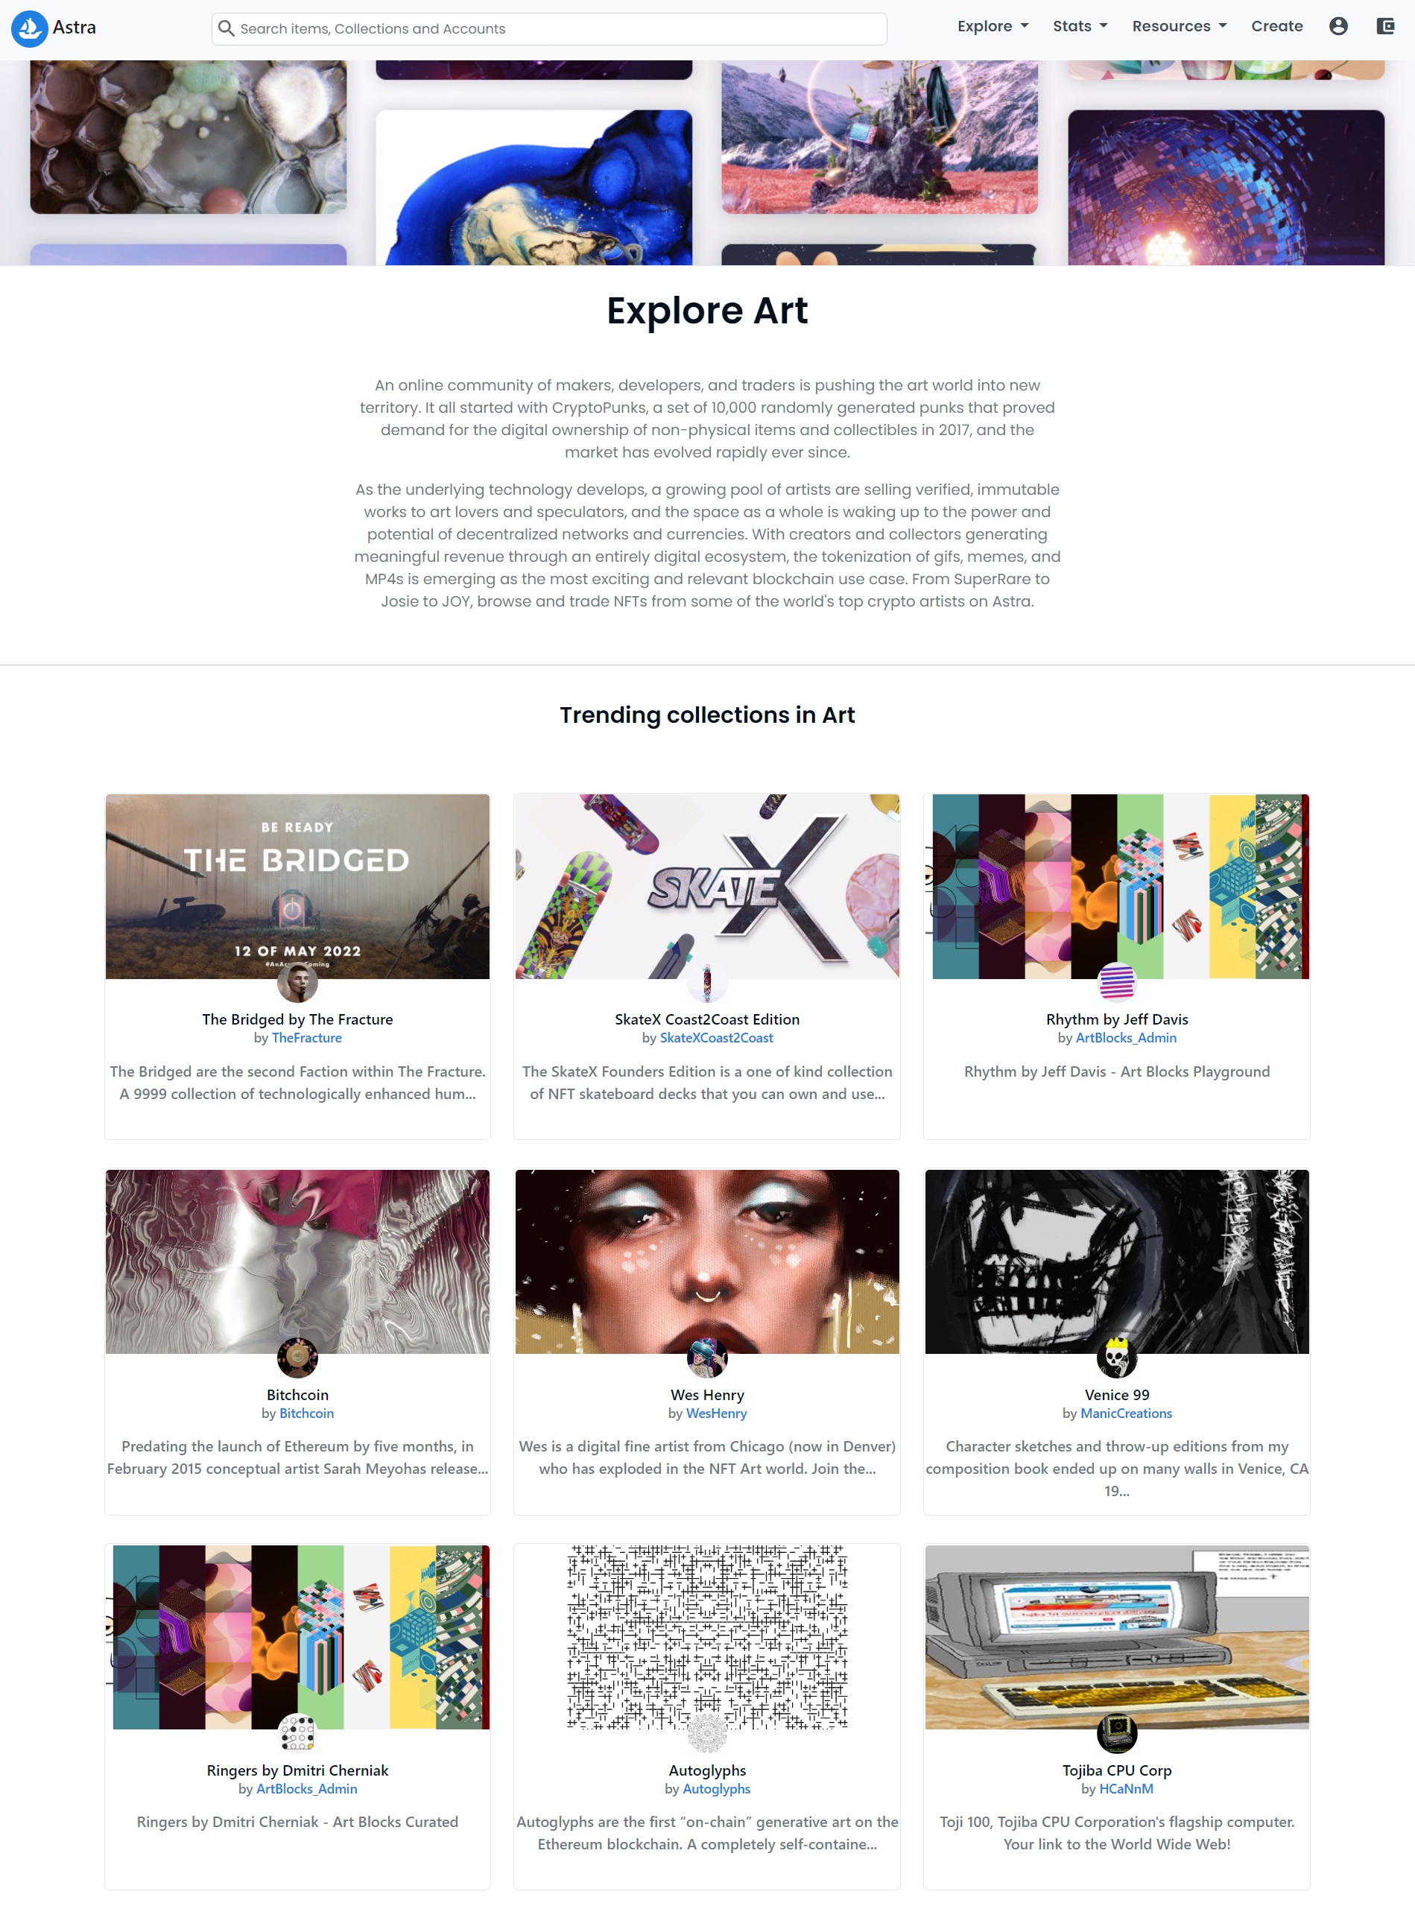

Individual pages for each of collection categories. Shows all the NFT collection of that category. All these cards are clickable and redirects user to the collection’s page.

1. **NFT Collection (100+ dynamic pages)**

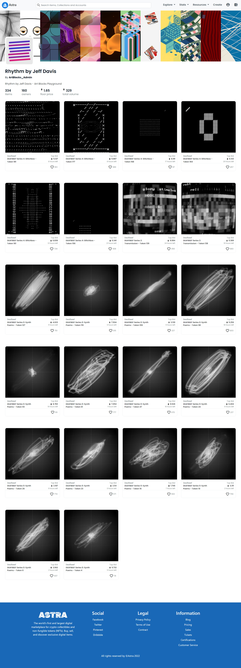

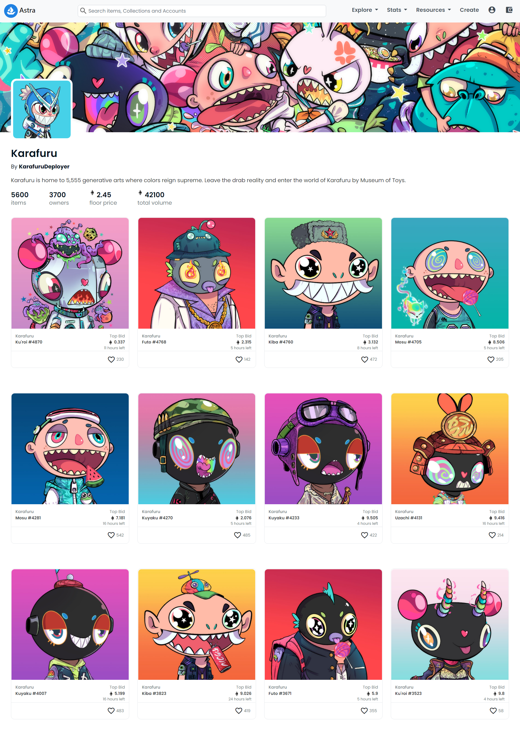

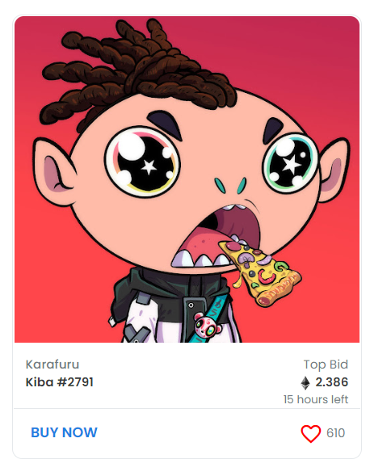

Users can view the live auction price. Moreover, they can click the buy button to place a bid themselves, or click the favourite button to add the NFT as a favourite to their account.

1. **Resources**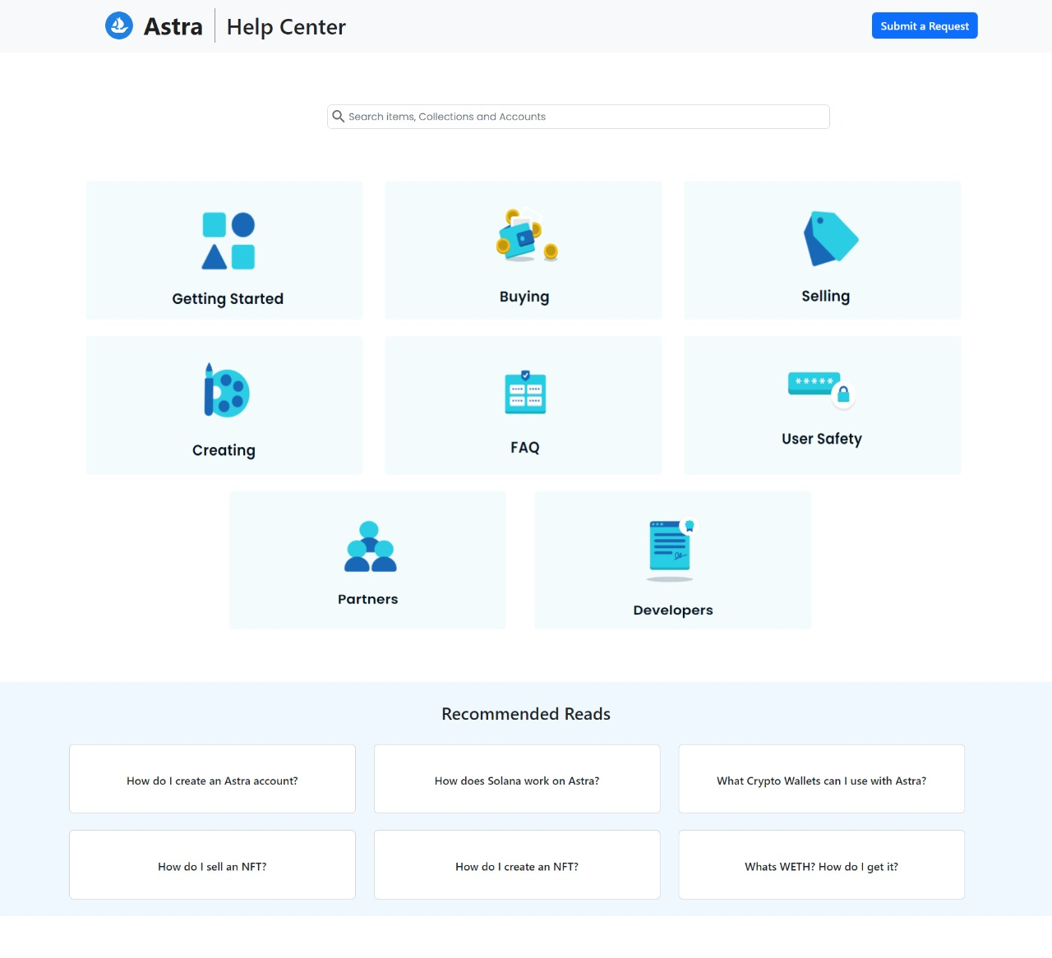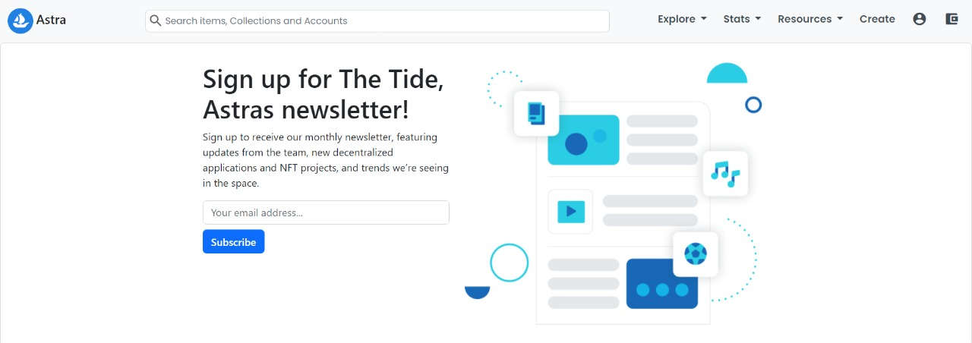

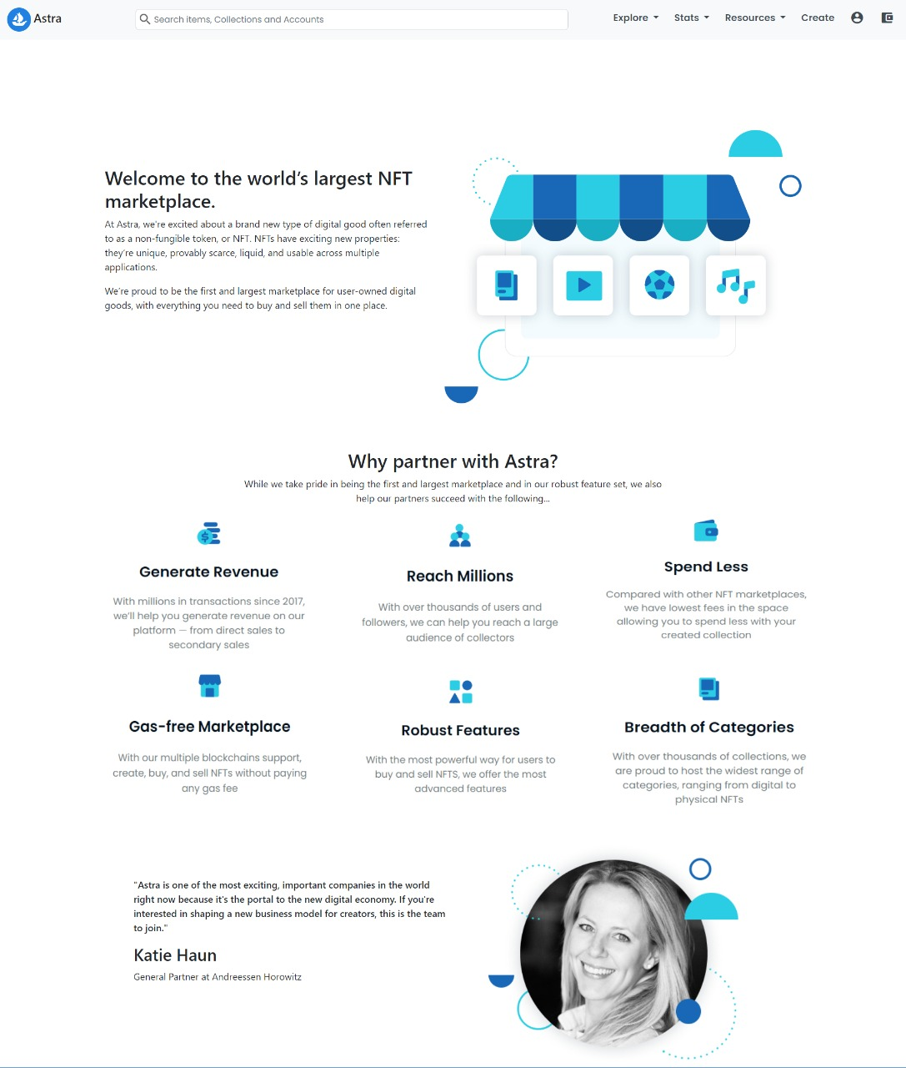

Functional And Non-functional requirements

The website implements a set of multiple enhanced and complicated of functionalities which allow users to fulfill their desired goals specifically related to the NFT marketplace.

The core purpose of this platform is to allow users to buy and sell their digital assets through the means of blockchain technology. With cryptocurrency, anyone can purchase or sell their digital assets such as NFTs on our marketplace. Moreover, they can explore different collections and view different NFTs to discover what’s popular.

Each user also has their own accounts page where they can view their owned assets. They are also providing a functionality to create their own NFT to sell on the marketplace.

The website allows users to connect their MetaMask or WalletConnect crypto wallet with the website giving them the functionality to interact with the website at a much detailed and deep level such as buying or selling NFTs or keeping a track of their personal favorites

The website also provides continuous and real-time statistics so they users stay in the loop about how well their favorite collection / NFT is doing.

Other functionalities like search operations, rankings, activities are also provided.

Conclusion

Building an NFT- market place frontend has challenged us in multiple areas and will helped us acquire knowledge in different domains. By adding backend functionality, we have built a full-scale project that we can use in future. Several different libraries and software’s were required for this which helped us master skills beyond what is being taught in the class.